# Python Pandas Exercise

This Pandas exercise project will help Python developers to learn and practice pandas. Pandas is an open-source, BSD-licensed Python library. Pandas is a handy and useful data-structure tool for analyzing large and complex data.

Practice DataFrame, Data Selection, Group-By, Series, Sorting, Searching, statistics. Practice Data analysis using Pandas.

In this exercise, we are using **Automobile Dataset** for data analysis. This Dataset has different characteristics of an auto such as body-style, wheel-base, engine-type, price, mileage, horsepower, etc.

[Automobile_data setDownload Automobile Dataset](https://pynative.com/wp-content/uploads/2019/01/Automobile_data.csv)

**Exercise 1: From the given dataset print the first and last five rows**

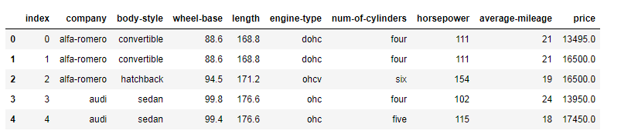

### Exercise 2: Clean the dataset and update the CSV file

Replace all column values which contain ?, n.a, or NaN.

### Exercise 3: Find the most expensive car company name

Print most expensive car’s company name and price.

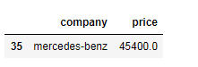

### Exercise 4: Print All Toyota Cars details

**Expected Output**:

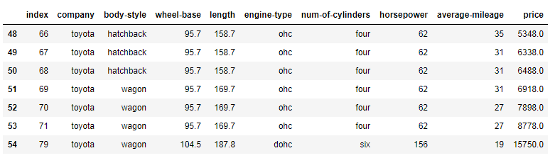

### Exercise 5: Count total cars per company

**Expected Outcome**:

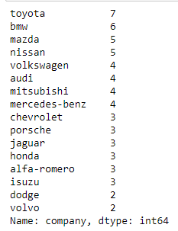

### Exercise 6: Find each company’s Higesht price car

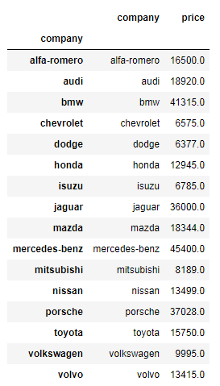

### Exercise 7: Find the average mileage of each car making company

**Expected Output**:

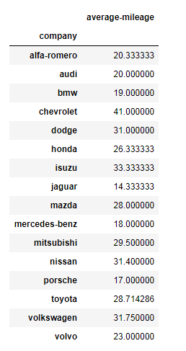

### Exercise 8: Sort all cars by Price column

**Expected Output**:

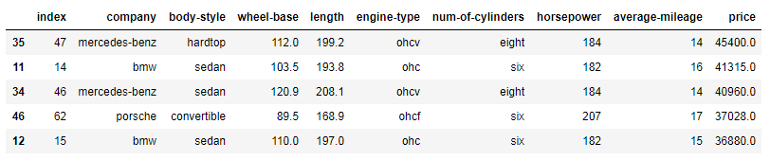

### Exercise 9: Concatenate two data frames using the following conditions

Create two data frames using the following two [dictionaries](https://pynative.com/python-dictionaries/).

GermanCars = {'Company': ['Ford', 'Mercedes', 'BMV', 'Audi'], 'Price': [23845, 171995, 135925 , 71400]}

japaneseCars = {'Company': ['Toyota', 'Honda', 'Nissan', 'Mitsubishi '], 'Price': [29995, 23600, 61500 , 58900]}

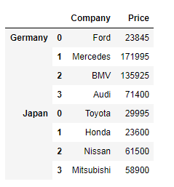

### Exercise 10: Merge two data frames using the following condition

Create two data frames using the following two Dicts, Merge two data frames, and append the second data frame as a new column to the first data frame

Car_Price = {'Company': ['Toyota', 'Honda', 'BMV', 'Audi'], 'Price': [23845, 17995, 135925 , 71400]}

car_Horsepower = {'Company': ['Toyota', 'Honda', 'BMV', 'Audi'], 'horsepower': [141, 80, 182 , 160]}

